Question 1: The final score of the World Cup finals of football is France 4 and Croatia 2. Please use a control structure to print the results as Team ---- Wins -----.

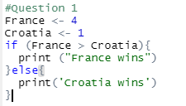

Output :

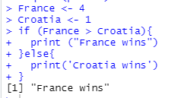

Question 2: The mtcars data set has several factor variables. However, R is reading them as numeric. Please convert them into factors using a for loop. Please use column 8 to 11 for the loop.

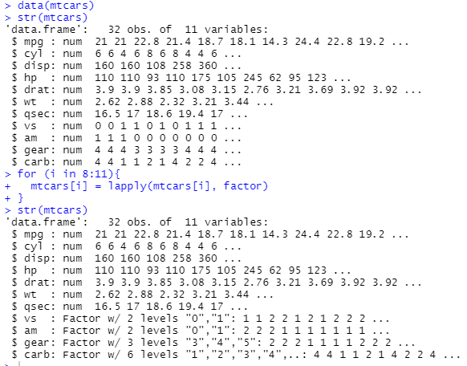

Question 3: Write a function to get the percentage of NAs in each column.

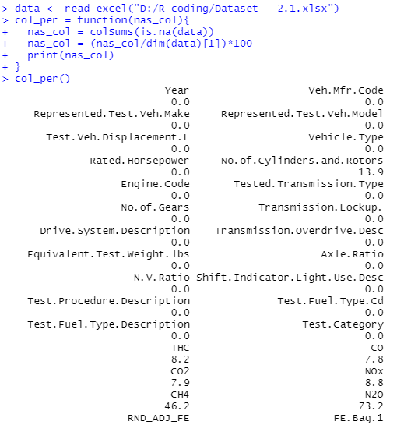

Question 4: Write a function to get the percentage of NAs in each row.

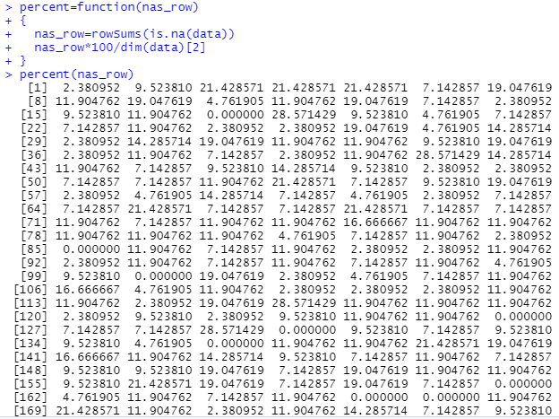

Question 5: Write a function to get a summary of numeric columns (use the summary function) such as THC, CO, CO2, and so on in the data set. With the same function, try to generate box plot using base R

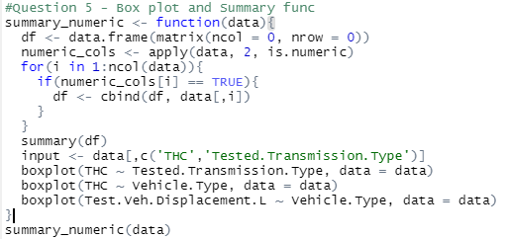

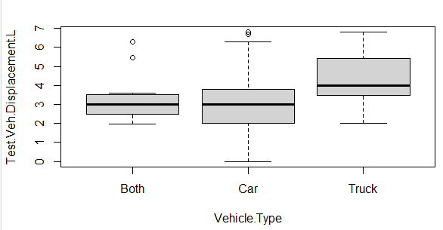

Question 6: Write a function to create histograms of numeric columns, such as THC, CO, CO2, and so on in the data set. Use ggpot2 to generate figures.

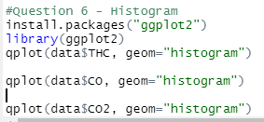

Attaching Histogram of last CO2 –

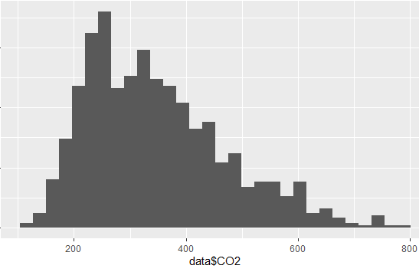

Question 7: The data set contains date columns. All of these date columns are untidy. Please create a better formatted data set. The date should be dd/mm/yyyy in the final format. Use columns 2, 3, and 5 only

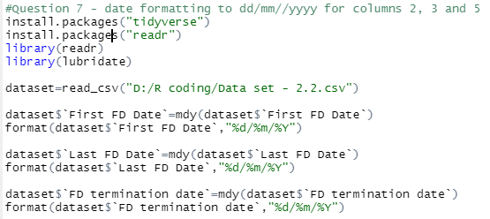

Question 8: The date of birth column contains months in string format. Please create a tidy data column with months in numeric format. Now your data should be similar to the previous question.

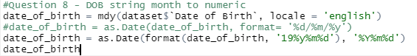

Question 9: Convert all dates into date format; they are currently in character variable format.

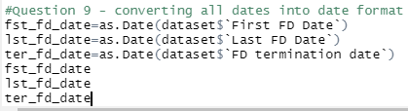

Question 10: Create a new column age based on the date of birth column and the first FD column. Date format is necessary to do basic arithmetic.

